**Brilliant Energy Institute**

**Office of the Vice President, Research and Innovation**

**Ontario Tech University**

**BEI Energy News**

**Produced weekly**

April 4th, 2025

**BEI News**

**Hydrogen Energy Workshop**

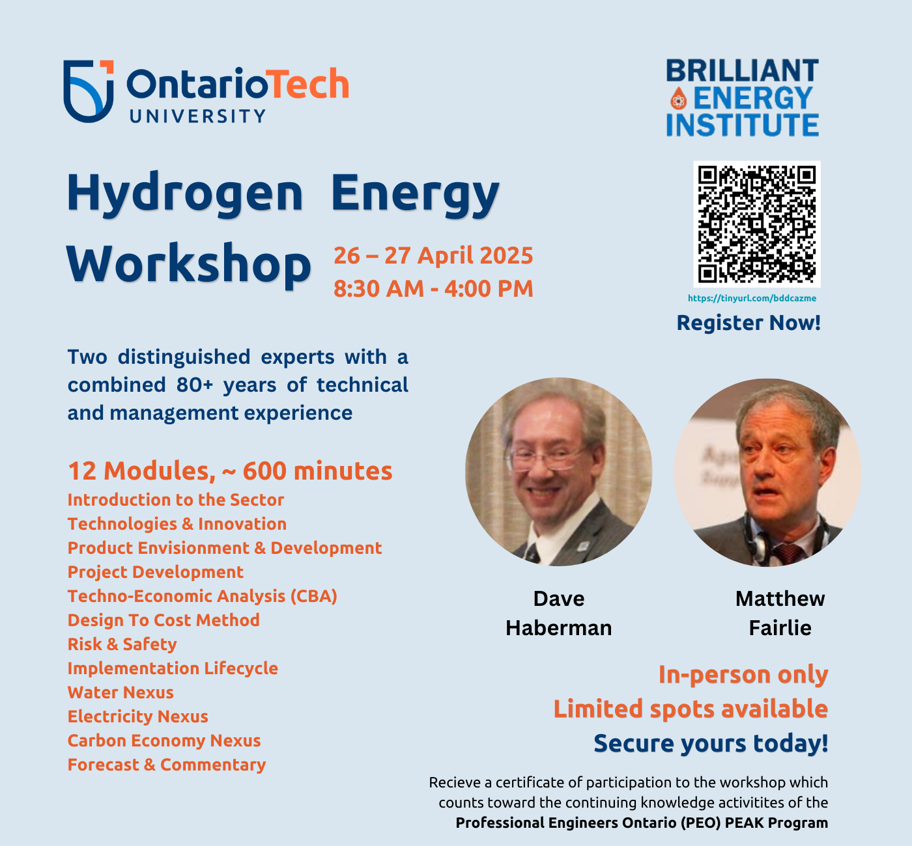

<https://research.ontariotechu.ca/discover-research/iaea-collaborating-centre/hydrogen-workshop-apr-2025/index.php>

Join the Brilliant Energy Institute at Ontario Tech University for a two-day Hydrogen Energy Workshop on Saturday and Sunday, April 26-27, 2025. Led by industry experts with a collective 80+ years of experience, this workshop offers an in-depth exploration of hydrogen technology and its real-world applications. Designed for professionals and students, the event will feature interactive discussions, case studies, and expert insights to enhance your understanding of hydrogen’s role in the future of energy.

**Ontario Tech News**

**Autonomous Drive Club (ADC) Data Fusion Challenge**

**Hydrogen**

**Ontario Doubling Hydrogen Innovation Fund to $30 Million to Protect Ontario Jobs – Ontario Newsroom**

<https://news.ontario.ca/en/release/1005717/ontario-doubling-hydrogen-innovation-fund-to-30-million-to-protect-ontario-jobs>

Ontario is doubling its Hydrogen Innovation Fund to $30 million, to strengthen the province's clean-energy leadership and protect local jobs. The expanded fund will support projects integrating hydrogen into electricity grids and sectors like transportation and manufacturing, potentially creating thousands of jobs. Energy Minister Stephen Lecce emphasized that hydrogen could meet nearly 20 per cent of Canada's energy demand by 2050, reducing dependency on the U.S. market. This initiative builds on Ontario’s Low-Carbon Hydrogen Strategy, positioning the province as a global hub for hydrogen innovation.

**Electric Vehicles**

**EV rebates under review as B.C. looks to offset cost of removing carbon tax - CBC**

<https://www.cbc.ca/lite/story/1.7499447>

B.C. is reviewing its electric vehicle (EV) rebates and other parts of the Clean B.C. program as it faces a $1.8-billion budget gap from ending the consumer carbon tax. Premier David Eby signalled possible cuts, though Energy Minister Adrian Dix says support for heat pumps will remain. The review comes amid declining EV sales, and experts warn that removing rebates could further undermine emissions targets. The provincial Go Electric rebate currently provides between $500 and $4,000 for EV and hybrid purchases, varying by vehicle range and buyer income.

**Energy Systems**

**Not ‘science fiction’: B.C. company touts big milestone in fusion power generation – Global News**

<https://globalnews.ca/news/11103324/bc-fusion-reaction-milestone/>

B.C.-based General Fusion has achieved a significant milestone in fusion energy, successfully forming a magnetized plasma in its prototype machine. The company plans to compress the plasma to trigger fusion, creating potentially limitless zero-carbon electricity. General Fusion hopes to reach the critical "scientific breakeven" point by late 2026, proving the technology's viability. Supported by significant public and private investments, the team says its work brings fusion power from "science fiction" closer to reality.

**Energy Policy**

**Joseph Mancinelli: Building an energy plan to power our economy – National Post**

<https://nationalpost.com/opinion/building-an-energy-plan-to-power-our-economy>

Labourers International Union of North America (LiUNA) Joseph Mancinelli warns that escalating U.S. tariffs threaten Canadian energy workers and broader economic stability. Stressing the interconnectedness of Canadian and U.S. economies, he urges Canada to invest heavily in infrastructure and pursue diverse energy projects, particularly nuclear power, as seen in Ontario’s successful approach. Mancinelli emphasizes the need for federal leadership to push projects forward, protect jobs, and foster economic security. He calls for cooperation, not conflict, to ensure both countries' shared prosperity and energy security amid ongoing trade tensions.

**Manitoba electricity rates could rise 10.9 per cent over three years – Toronto Star**

<https://www.thestar.com/news/canada/manitoba/manitoba-electricity-rates-could-rise-10-9-per-cent-over-three-years/article_032884ed-58af-55fd-b07b-6facfd5cc0b9.html>

Manitoba Hydro has applied to raise electricity rates by 3.5 per cent each year over the next three years, totalling nearly 10.9 per cent, to address aging infrastructure, capacity expansion, and debt challenges. The Crown corporation cited reduced hydroelectric generation caused by drought and warned about necessary upgrades to aging equipment. This application follows a one-year rate freeze by the provincial NDP government aimed at affordability. Consumer advocates previously cautioned that the freeze might merely postpone higher rate increases.

**Advocates call for energy-poverty strategy as N.B. Power rates increase – CBC**

<https://www.cbc.ca/news/canada/new-brunswick/nbpower-rate-hike-protest-fredericton-1.7499051>

Advocates in New Brunswick are urging the government to develop an energy-poverty strategy following a 9.6 per cent increase in N.B. Power rates. Residential rates have risen by about 30 per cent over the last three years as the utility struggles financially. Premier Susan Holt acknowledged the difficulties but said the government found no mechanism to prevent the hike. Advocates argue immediate government intervention is essential to protect low-income residents already strained by rising living costs.

**Promising new technologies face market uncertainty in pivotal moment for global energy innovation – IEA**

<https://www.iea.org/news/promising-new-technologies-face-market-uncertainty-in-pivotal-moment-for-global-energy-innovation>

Energy innovation is at a critical turning point globally, facing both significant progress and emerging investment uncertainties. While corporate and public R&D have grown steadily, venture capital funding recently dropped over 20 per cent, hindering future advancements. China leads in energy patents, particularly in low-emissions tech, but demonstration projects vital for commercializing new technologies are stalled by inflation and policy issues. Increased public investment and international cooperation are urged to sustain momentum and meet global energy and climate goals.

*Do you have any milestones, events, or news updates to share with the energy community? Email your submission to*[*BrilliantEnergy@ontariotechu.ca*](mailto:BrilliantEnergy@ontariotechu.ca)*for consideration in an upcoming edition.*

Thank you.

The Brilliant Energy Institute News Team  
[brilliantenergyinstitute.ca](http://www.brilliantenergyinstitute.ca/)

*(With a little help from ChatGPT)*